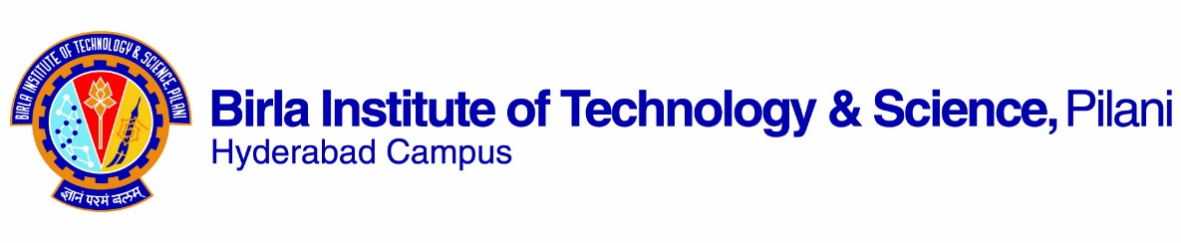

**FIRST SEMESTER 2021-2022**

# Course Handout Part II

Date: 20-08-2021

In addition to part-I (General Handout for all courses appended to the time table) this portion gives further specific details regarding the course.

***Course No.* : ME F425**

## **Course Title : Additive Manufacturing**

## **Instructor-in-Charge : Dr. Pavan Kumar P**

**Scope and Objective of the Course:** Introduction to Additive Manufacturing (AM), Computer Aided Design (CAD) for AM, material science aspects in AM, different materials used in AM, use of multiple materials, multifunctional and graded materials in AM, role of solidification rate. Various AM processes, powder‐based AM processes involving sintering and melting, printing processes (droplet based 3D printing), fused deposition modelling (FDM), laminated object manufacturing (LOM), stereolithography (SLA), micro‐ and nano‐AM processes. Modelling in AM. Transport phenomena models: temperature and fluid flow, molten pool formation, various case studies ‐ modelling of fusion based AM process, powder bed melting based process, droplet based printing process. Applications of AM in aerospace, automotive, electronics industries and biomedical applications.

**Textbooks:**

1. Ian Gibson, David Rosen, Brent Stucker, “Additive Manufacturing Technologies”, Springer, 2015, NY.

**Reference books**

1. Dongdong Gu, “Laser Additive Manufacturing of High-Performance Materials”, Springer Publ. 2014.
2. Andreas Gebhardt, “Understanding Additive Manufacturing”, Hanser Publishers, 2011.
3. Venuvinod, Patri K., Ma, Weiyin, “Rapid Prototyping: Laser-based and Other Technologies”, Springer, 2004, NY, USA.
4. Chee Kai Chua, Kah Fai Leong and Chu Sing Lim, “Rapid Prototyping: Principles and Applications”, World Scientific Publishing Company, 3rd Edition, India, 2008.

**Course Plan:**

| **Lecture No.** | **Learning objectives**  **(Modules)** | **Topics to be covered** | **Chapter in the Text Book** |
| --- | --- | --- | --- |
| 1-2 | M1: Introduction to Additive Manufacturing (AM) | Introduction and basic principles of AM, What is AM, the term what for AM, the generic AM process chain with eight steps, benefits of AM, distinction between AM and CNC machining, example AM parts | T1: Ch-1 |
| 3-4 | M2: Development of AM Technology | Classification of AM processes, liquid polymer systems, powder/discrete particle systems, molten material AM systems, solid sheets systems, metal systems, hybrid systems. Maintenance of equipment and materials handling issues. Computers and Computer Aided Design technology, other related/associated technologies, the use of layers and layered technique of AM. | T1-Ch2 & Ch3 |
| 5-7 | M3: Vat Polymerization Techniques and Stereolithography (SLA) | Vat photo-polymerization (VP) processes, vat photo-polymerization materials, reaction rates, laser scan vat photo-polymerization, photo-polymerization process modeling, vector scan VP machines, scan patterns, vector scan micro-VP, mask projection VP technologies and processes, two-photon VP, process benefits and drawbacks, mathematical modeling of SLA. | T1-Ch4 |
| 8-12 | M4: Powder‐based AM processes | Powder‐based AM processes involving sintering and melting, materials, powder fusion mechanisms, process parameters and modeling, powder handling, PBF process variants and commercial machines, process benefits and drawbacks, mathematical modeling of SLS. | T1 |
| 13-18 | M5: Fused deposition modelling (FDM) | Extrusion-based systems, basic principles, plotting and path control, fused deposition modeling from Stratasys, FDM materials, limitations of FDM, bio-extrusion, other processes, mathematical modeling of FDM. | T1 |
| 19-20 | M6: Laminated object manufacturing (LOM) | Sheet lamination processes, materials, material processing fundamentals, ultrasonic additive manufacturing (UAM) | T1 |
| 21-26 | M7: Metal AM | Direct energy metal deposition processes by melting, process description, material delivery, metal AM machines and systems, process parameters, materials and microstructures, structure-property relationships, transport phenomena models: temperature and fluid flow, molten pool formation, various case studies, benefits and drawbacks. | T1 |
| 27-33 | M8: Software issues in AM | Conversion of CAD to STL, STL file binary/ASCII, Creating STL files from CAD system, Calculation of each slice profile, technology-specific elements. Problems with STL files. STL file manipulation, viewers, STL file manipulation on the AM machine. Beyond the STL file, direct slicing of CAD model, color models, multiple materials, use of STL for machining. Additional software to assist AM, survey of software functions, AM process simulation using FEM. The AM file format. | T1 |
| 34-38 | M9: Miscellaneous Aspects of AM | Post-processing, design for AM, rapid tooling |  |
| 39-42 | M10: Applications for AM | Disruptive Innovation, The Future of Low-Cost AM, Selection Methods for a Part, Challenges of Selection, Production Planning and Control, Applications of AM in aerospace, automotive, electronics industries and biomedical applications, business opportunities and future directions, the impact of low-cost AM systems. Application areas not involving CAD modeling. |  |

**Evaluation Scheme:**

|  |  |  |  |  |
| --- | --- | --- | --- | --- |
| **Component** | **Duration**  **(min)** | **%Weightage (Marks)** | **Date & Time** | **Nature of Component** |
| Midsem Test | 90 | 30% | 21/10/2021 3.30 -5.00PM | OB |
| Experiential Learning (Project Assignments) | - | 20% |  | OB |
| Quizzes |  | 10% |  | OB |
| Comprehensive Examination | 120 | 40% | 21/12 FN | OB |

**Chamber Consultation Hour:** To be declared in the first lecture class.

**Notices:** On CMS.

**Make-up Policy: Only for genuine cases of hospitalization due to illness, on production of medical certificate and with prior email intimation.**

**Academic Honesty and Integrity Policy:** Academic honesty and integrity are to be maintained by all the students throughout the semester and no type of academic dishonesty is acceptable.

**INSTRUCTOR-IN-CHARGE**